1: Program to print hello world import java.io.*;

public class hello

{

public static void main(String[] args)

{

System.out.println("Hello World");

}

}

OUTPUT..

* 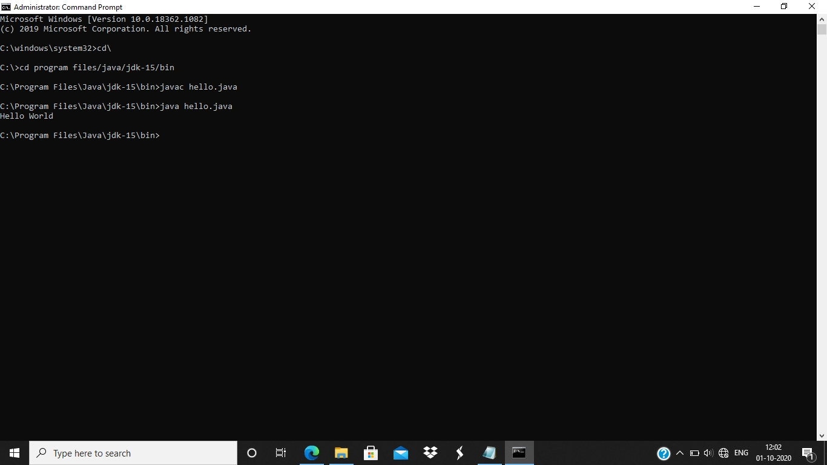

2:Program to find the largest of three numbers

import java.io.*;

import java.util.*; public class large

{

public static void main(String[] args)

{

Scanner sc=new Scanner(System.in);

int a,b,c;

System.out.println("Enter the first number");

a=sc.nextInt();

System.out.println("Enter the second number");

b=sc.nextInt();

System.out.println("Enter the third number");

c=sc.nextInt();

if(a>b&&a>c)

System.out.println(a + " " + "Is largest"); else if(b>a&&b>c)

System.out.println(b + " " + "Is largest");

else

System.out.println(c + " " + "Is Largest");

}

}

OUPUT:

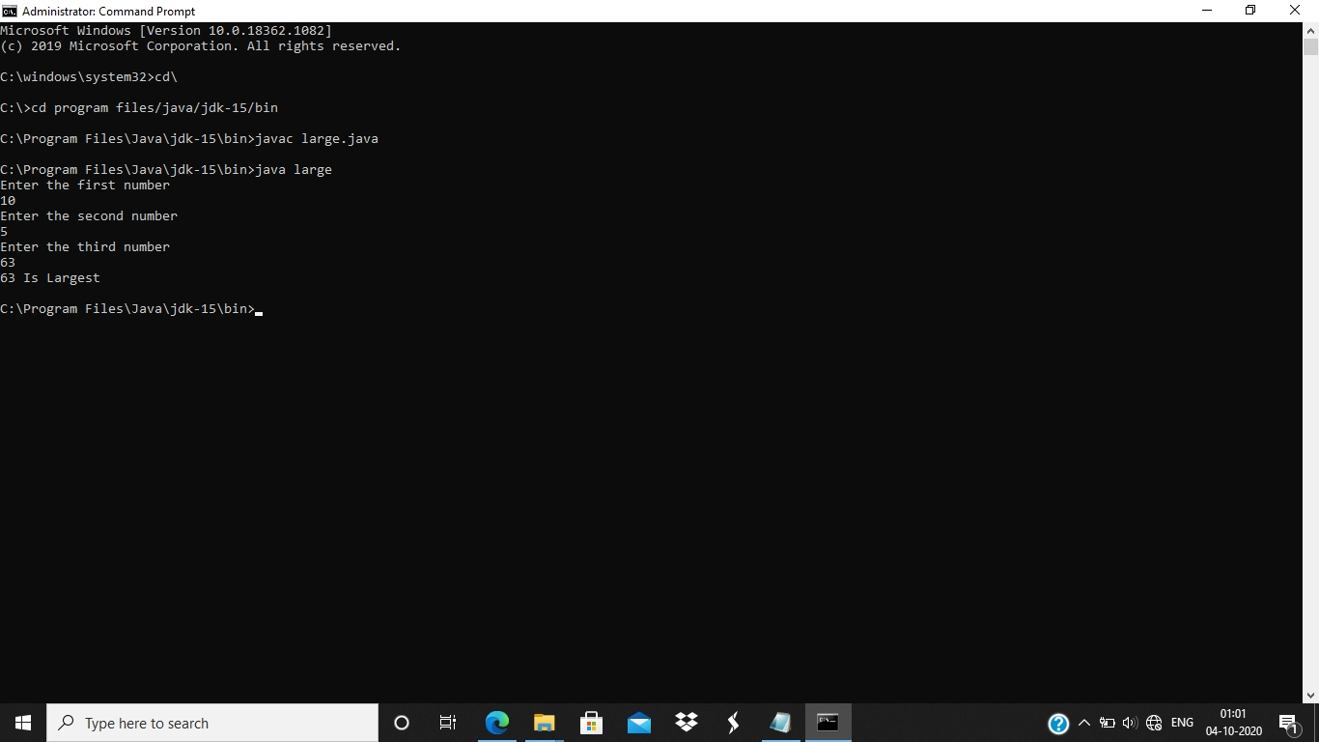

3 : Program to print the values from 1 to n

import java.util.*;

public class input

{

public static void main(String[] args)

{

Scanner sc=new Scanner(System.in);

int n;

System.out.println("Enter the value of n"); n=sc.nextInt();

System.out.println("Printing the values from 1 to n"); for(int i=1;i<=n;i++)

{

System.out.println(i);

}

}

}

OUTPUT:

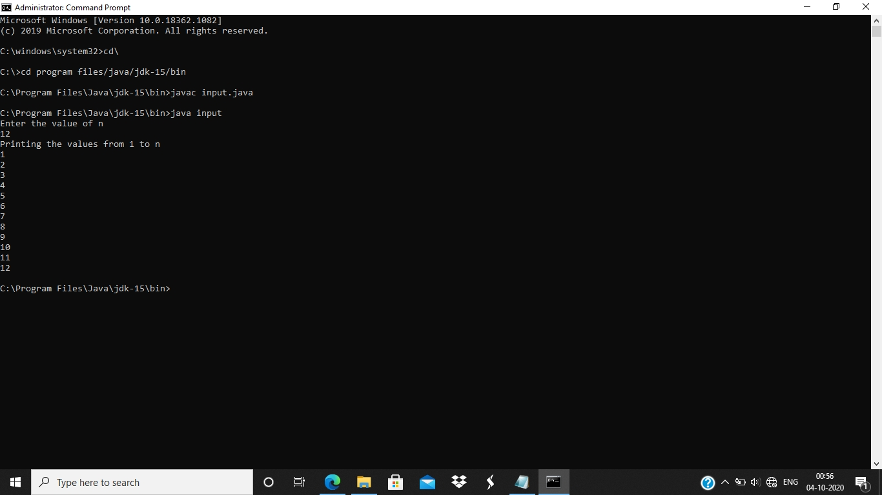

4: Write a program to print the pattern

import java.io.*;

import java.util.*; import java.lang.*; public class firstprogram1

{

public static void pattern(int n)

{

int k=1;

for(int i=1;i<=n;i++)

{

for(int j=1;j<=i;j++)

{

System.out.print(k + " "); k++;

}

System.out.println();

}

}

public static void main(String[] args)

{

Scanner sc=new Scanner(System.in);

int num;

System.out.println("Enter the number of rows"); num=sc.nextInt(); pattern(num);

}

}

OUTPUT:

OUTPUT IS shred in the next screen…

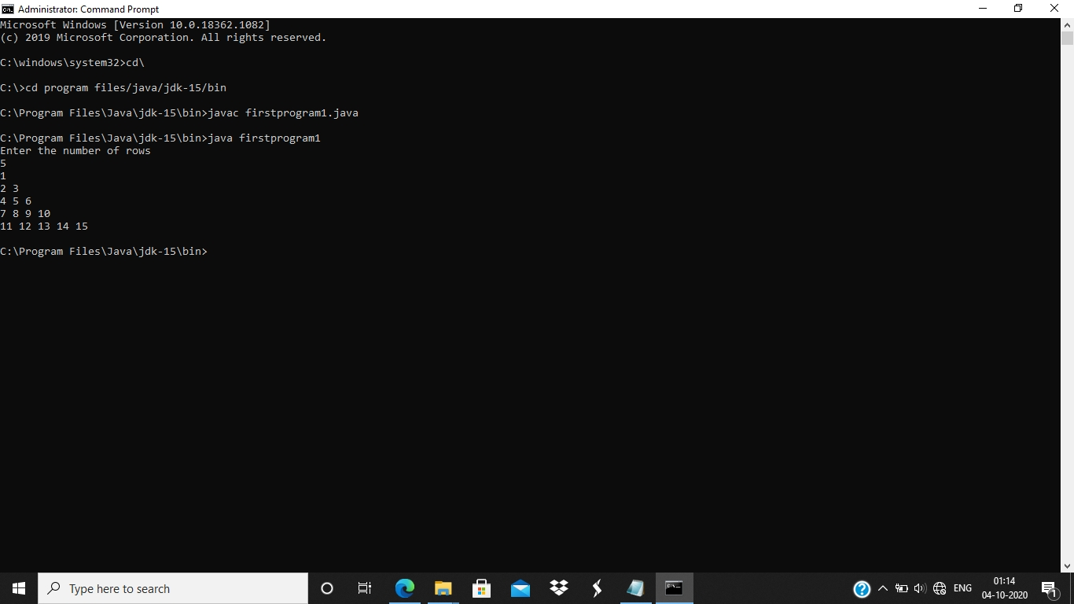

5: program to calculate the grade from cie and see

import java.io.*;

import java.lang.*; import java.util.*; public class cie_and_see

{

private static double cie; private static double see; public static void read()

{

Scanner sc=new Scanner(System.in);

System.out.println("Enter the CIE marks out of 50");

cie=sc.nextFloat();

System.out.println("Enter the SEE marks out of 100"); see=sc.nextFloat();

}

public static void calc()

{ read();

double total=Math.round(cie+((see)/2)); System.out.println("Total marks obtained is " + total); if(total>=90&&total<=100)

{

System.out.println("Grade obtained is " + "S");

}

else if(total>=80&&total<90)

{

System.out.println("Grade obtained is " + "A");

}

else if(total>=70&&total<80)

{

System.out.println("Grade obtained is " + "B");

}

else if(total>=60&&total<70)

{

System.out.println("Grade obtained is " + "C");

}

else if(total>=50&&total<60)

{

System.out.println("Grade obtained is " + "D");

}

else if(total>=40&&total<50)

{

System.out.println("Grade obtained is " + "E");

}

else

{

System.out.println("Grade obtained is " + "F");

}

}

public static void main(String[] args)

{ calc();

}

}

OUTPUT:

Output is shared in the next screen..

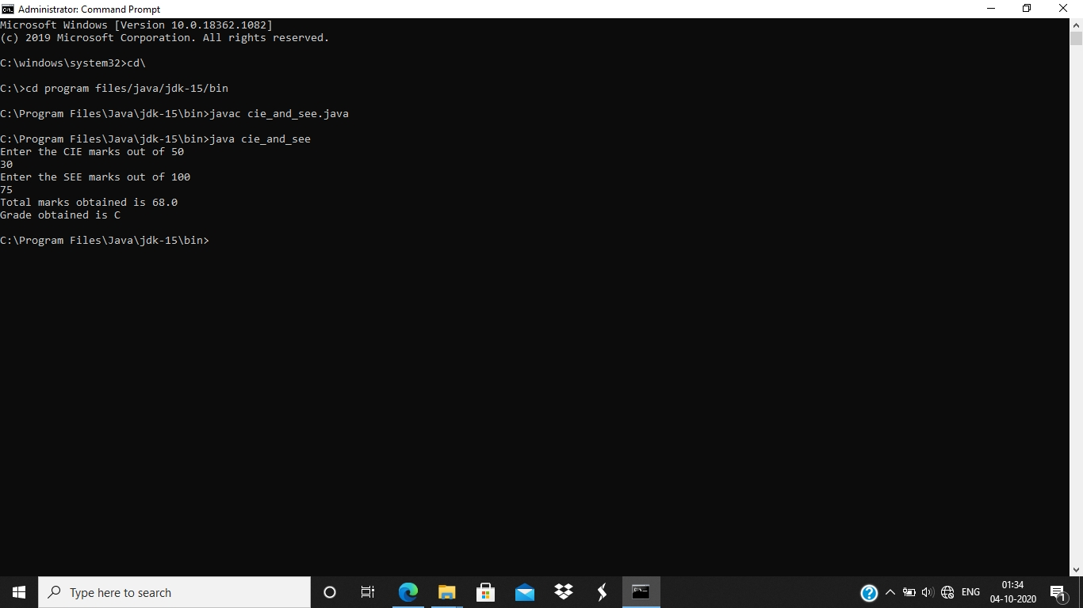

6: write a program to print all prime numbers between two numbers

import java.io.*;

import java.lang.*; import java.util.*; public class prime

{

public static boolean checkprime(int n)

{

int flag=1; for(int i=2;i<=n/2;i++)

{

if(n%i==0)

{

flag=0; break; }

}

if(flag==1)

{

return true;

}

else

{

return false;

}

}

public static void main(String[] args)

{ int a,b;

Scanner sc=new Scanner(System.in); System.out.println("Enter the first number");

a=sc.nextInt();

System.out.println("Enter the second number");

b=sc.nextInt();

System.out.println("Prime numbers are "); for(int i=a;i<=b;i++)

{

if(checkprime(i))

{

System.out.println(i + " " + "is prime");

}

}

}

}

OUTPUT:

